Interface Design Description

Advanced Orchestration Service

**Abstract**

This document describes the interaction with the Advanced Orchestration Service using REST/HTTP with JSON payloads.

1. Introduction

This document describes the Orchestration Advanced Logic Service and how it can be accessed using HTTP methods and JSON payloads.

1. Overview

This Service can be invoked with a simple REST call to the Orchestrator System to the specific Service URI.

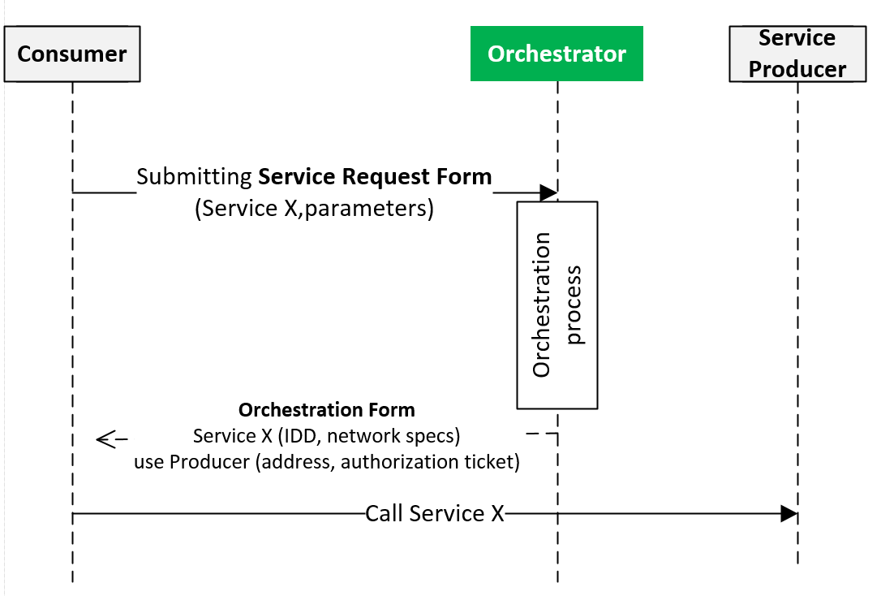

1. Interface

The Orchestration Service is offered through 2 different interfaces. The default interface used by most Systems give options to the requester System to influence the Orchestration process, but also requires a complex request payload with mandatory fields. The 2nd interface is specifically implemented for low-level devices, where a request payload is not needed, and only default Orchestration Store based Orchestration process can happen. Table 1 describes these two interfaces.

Table 1 Function description

|  |  |  |  |  |
| --- | --- | --- | --- | --- |
| **Function** | **URL subpath** | **Method** | **Input** | **Output** |
| Orchestration | “/orchestrator/orchestration” | POST | **ServiceRequestForm** | 200 OK,  BAD_PAYLOAD,  DATA_NOT_FOUND |
| Orchestration | “/orchestrator /orchestration/ {systemName}” | GET | **-** | 200 OK,  BAD_PAYLOAD,  DATA_NOT_FOUND |

The main Service interface is accessible via a POST request to the Service URI. The data is to be sent in JSON or XML.

The Orchestration URI is <http://LocalOrchestratorIP:port/orchestrator/orchestration> by default.

1. **Service Request Form**



**Figure 1. The Service Request Form**

|  |  |
| --- | --- |
| **Field** | **Description** |
| RequesterSystem: ArrowheadSystem | The ArrowheadSystem identifier that is requesting the orchestration. Mandatory field. |
| RequesterCloud: ArrowheadCloud | Not to be used by Application Systems. This field is only used when there is an inbound request from another Cloud. This can only be submitted by the Gatekeeper. |
| RequestedService: ArrowheadService | Not mandatory. When not filled out, the Orchestrator operate in the ”default configuration” mode. When filled out, other fields will affect how the orchestration will work – but the Service will be specified by the Consumer in advance then. |
| OrchestrationFlags: HashMap | These flags can be set to tailor the orchestration process. |
| PreferredProviders | There can be a list from the Consumer stating which other Application Systems (even from other Clouds) it wishes to connect. If this field is filled out, the Orchestrator will try to facilitate these preferences. |
| RequestedQoS | This object will be presenting the Consumer’s selected QoS level. Not implemented. |

The Orchestration flags are optional in the payload, but have the following meaning if set (the color coding suggests which flag affects which Core System):

|  |  |
| --- | --- |
| triggerInterCloud | Setting this flag skips other processes, and triggers the GSD and then the ICN processes. For debug and testing purposes. |
| externalServiceRequest | This flag can only be set by the Gatekeeper. It means that the Service Request is from another Cloud and an inbound inter-Cloud orchestration is happening. |
| metadataSearch | This flag is set if the Consumer want filtering of Providers based on the submitted set of metadata key-value pairs. This happens in the Service Registry. |
| pingProviders | This is set if the Consumer wants the Service Registry to check whether the suitable Providers are online or their offer is invalid (forgot to revoke their entry). |
| storeOnlyActive | This flag is set if the Consumer wants the default configuration. If it specifies a Service then only that entry is returned, but if left empty, every Orch. Store entry marked isActive is returned. |
| matchmaking | This flag is set if the Consumer only wants one suitable Provider (the best). Requires custom matchmaker algorithm implemented in the Orchestrator (by default only the first one is returned). |
| onlyPreferred | If the Consumer can only accept orchestration where the Provider is from its list of preferred ones (submitted in the SRF). This leads to empty orchestration if no one on the list is available/suitable/usable. |
| generateToken | This is set, if the Consumer requests authorization token to be generated. |

***Note:*** *Not all flags are necessary to set. Only needed when it is set to true, since all flags are false by default.*

A request example:

In this example, a charging station is looking up all (matchmaking=false) the three car manufacturers’ servers (preferredProviders in preferredClouds for BMW and Audi and one local in the evopro Local Cloud) for charging management service. Only these three Providers are allowed (onlyPreferred=true) and since two of the Providers are not local, enableIntercloud=true.

**{**

"requesterSystem"**:**

**{**

"systemGroup"**:** "evopro_car_chargers"**,**

"systemName"**:** "charging_station1"**,**

"address"**:** "0.0.0.0"**,**

"port"**:** "8080"**,**

"authenticationInfo"**:** "info1"

**},**

"requestedService"**:**

**{**

"serviceGroup"**:** "energy"**,**

"serviceDefinition"**:** "ChargingReservations"**,**

"interfaces"**:** **[**"JSON"**]**

**},**

"requestedQoS"**:** "NotUsed"**,**

"orchestrationFlags"**:** **{**

"entry"**:** **[**

**{**

"key"**:** "triggerInterCloud"**,**

"value"**:** **false**

**},**

**{**

"key"**:** "externalServiceRequest"**,**

"value"**:** **false**

**},**

**{**

"key"**:** "enableInterCloud"**,**

"value"**:** **true**

**},**

**{**

"key"**:** "metadataSearch"**,**

"value"**:** **false**

**},**

**{**

"key"**:** "pingProviders"**,**

"value"**:** **false**

**},**

**{**

"key"**:** "overrideStore"**,**

"value"**:** **false**

**},**

**{**

"key"**:** "storeOnlyActive"**,**

"value"**:** **false**

**},**

**{**

"key"**:** "matchmaking"**,**

"value"**:** **false**

**},**

**{**

"key"**:** "onlyPreferred"**,**

"value"**:** **true**

**},**

**{**

"key"**:** "generateToken"**,**

"value"**:** **false**

**}**

**]**

**},**

"preferredProviders"**:**

**[**

**{**

"address"**:** " address2"**,**

"authenticationInfo"**:** "info2"**,**

"port"**:** "1"**,**

"systemGroup"**:** "BMW_systems"**,**

"systemName"**:** "server2"

**},**

**{**

"address"**:** " address3"**,**

"authenticationInfo"**:** "info2"**,**

"port"**:** "1"**,**

"systemGroup"**:** "AUDI_systems"**,**

"systemName"**:** "server2"

**},**

**{**

"address"**:** " address4"**,**

"authenticationInfo"**:** "info2"**,**

"port"**:** "1"**,**

"systemGroup"**:** "evopro_systems"**,**

"systemName"**:** "server2"

**}**

**],**

"preferredClouds"**:**

**[**

**{**

"operator"**:** "BMW"**,**

"cloudName"**:** "BMW_cloud"**,**

"address"**:** "address5"**,**

"port"**:** "8446"**,**

"gatekeeperServiceURI"**:** "gatekeeper"

**},**

**{**

"operator"**:** "AUDI"**,**

"cloudName"**:** "AUDI_cloud"**,**

"address"**:** " address6"**,**

"port"**:** "8446"**,**

"gatekeeperServiceURI"**:** "gatekeeper"

**}**

**]**

**}**

Orchestration Response



The Response consists of multiple Orchestration Forms.

|  |  |
| --- | --- |
| Service | The exact Service that has to be consumed (up to the interface and metadata description). This stems from the chosen Provider (from its entry in the Service Registry). |
| Provider | The Provider itself. |
| ServiceURI | The URL that provides the Service within: Provider’s_IP:port/serviceURI. Since the ArrowheadSystem class does not have an URL field. |
| AuthorizationToken | This string contains the encrypted token. |
| AuthorizationSignature | This string verifies that the local Authorization System generated the token. |
| Instruction | This string is used to pass on configuration type data. Currently only used at the isActive Store-based orchestration configuration requests. |

The response example:

Only the second favored System from BMW’s network is available right now to service. Its REST_JSON based interface is available addres3:1/reservation path.

**{**

"response"**:** **[**

**{**

"provider"**:** **{**

"address"**:** "address3"**,**

"authenticationInfo"**:** "tbd"**,**

"port"**:** "1"**,**

"systemGroup"**:** "AUDI_systems"**,**

"systemName"**:** "server2"

**},**

"service"**:** **{**

"interfaces"**:** **[**

"REST_JSON"

**],**

"serviceDefinition"**:** "ChargingReservations"**,**

"serviceGroup"**:** "energy"

**},**

"serviceURI"**:** "/reservation"

**}**

**]**

**}**

1. Security

This Service can be configured to work insecured (plain HTTP) or through TLS with X.509 certificates.

In its secure mode, only those Application Systems can request orchestration that belong to its Local Cloud (identified and checked using the CN field of the certificate).

1. Revision History

|  |  |  |  |  |
| --- | --- | --- | --- | --- |
| No. | Date | Version | Subject of Amendments | Author |
| 1 | 2016-08-23 | 0.1 | First edition | Csaba Hegedűs |
|  |  |  |  |  |

# Quality Assurance

|  |  |  |  |
| --- | --- | --- | --- |
| No. | Date | Version | Approved by |
| 1 |  |  |  |
| 2 |  |  |  |